ZSPEED PERFORMANCE "CMAK"
Clutch Movement Alteration Kit
Concentric Slave Cylinder CSC Delete

Thank you for choosing ZSpeed Performance
This is a guideline to install our CSC Delete kit "CMAK"
CMAK will delete the Concentric Slave cylinder in models that come with the OEM Nissan Plastic Concentric Slave Cylinder or "CSC"
CMAK is a direct bolt on kit with no modifications needed to install.

Fits:
2007-2008 Nissan 350Z
2009+ Nissan 370Z
2008+ Infiniti G37
2007-2008 Infiniti G35S Sport Sedans

Installation should be performed by a qualified automotive repair technician.
Items needed to install
- Blue Loc-tite or similar
- RTV Sealant
- Small amount Moly Based High Temp Grease

Step 1
DRAIN Transmission Fluid
Remove Transmission

Remove Stock CSC Clutch Slave Cylinder, Dust boot and pipe assy by removing the pipe clip & 2 bolts, Retain tube bracket bolt on the outside of the trans, You will use this to mount the dust cover later.
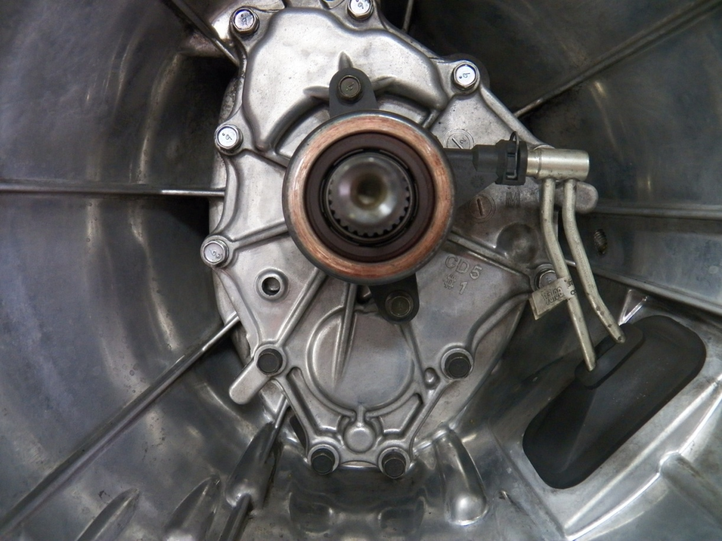
NOTE LOCATION OF LOWER BLACK COLORED FACTORY COVER BOLTS, THESE REQUIRE SEALER UPON INSTALLATION.

Step 2
Install CMAK Release Bearing Guide and Retainer plate onto front cover with supplied bolts (Use Loc-tite on threads) in same location as the stock CSC making sure center bearing guide aligns & centers under retainer plate. TQ bolts to factory spec of 80 inch lbs and loctite threads.
Remove 5 bolts as shown on front cover locations below.
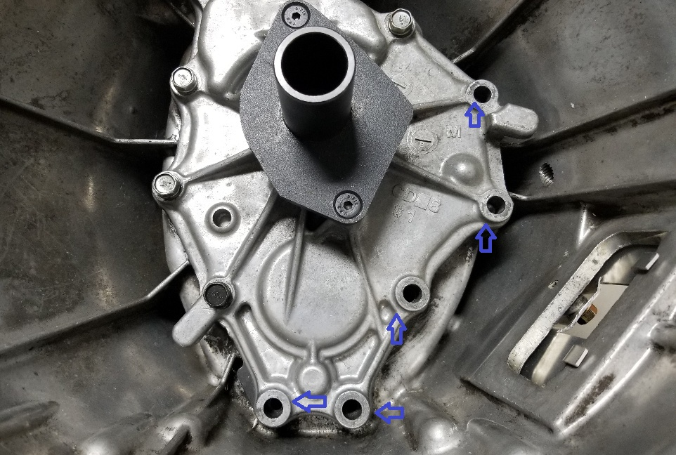

STEP 3
Install Throw Out Bearing On To Fork assy and Lightly Grease Points marked with blue triangles.

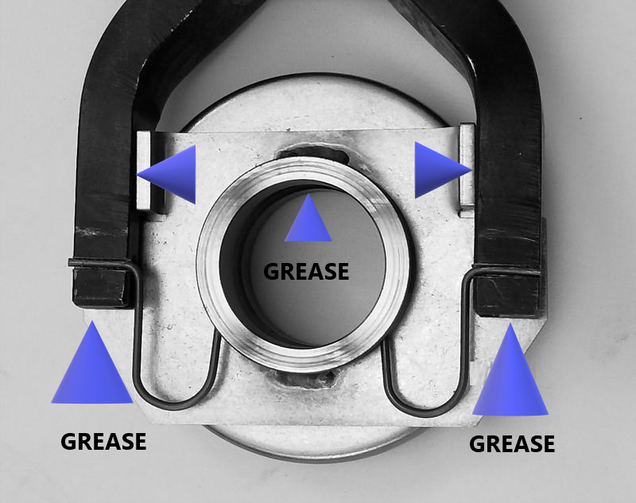

STEP 4
install CMAK Clutch Fork, Bearing and Bracket assembly with the 5 aluminum 1/2" thick spacers & 5 Black 55mm long bolts.
Apply RTV Sealer to Threads Of Lower 3 Bolts
Apply Loctite to Upper 2 Bolts.
To install the Clutch Fork Assembly and spacers you can temporally stick the aluminum spacers to the back side of the bracket with a light coat Permatex High-Tack adhesive etc to hold them in place while you mount the bracket. The (5) 1/2" thick aluminum spacers go between the transmission front cover and the clutch fork bracket assembly to space the bracket off the front cover.
DO NOT DISASSEMBLE FORK FROM BRACKET, THIS WILL VOID YOUR WARRANTY
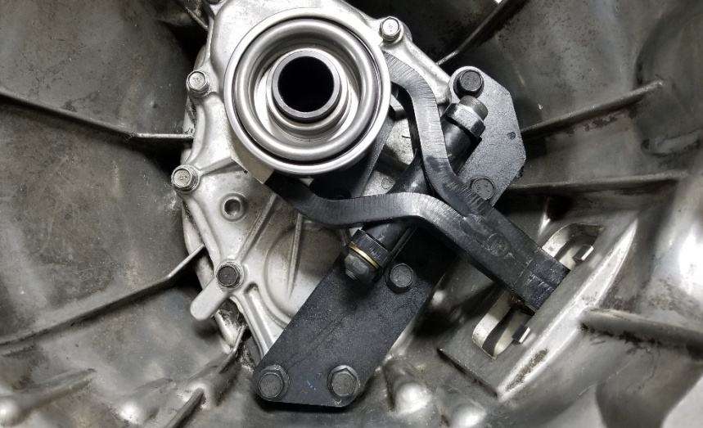

Tighten top and bottom 2 bolts on the the bracket finger tight while holding up of fork end slightly. (this centers the bracket) then finger tighten the other 3 bolts, TQ top and bottom bolts first to 20 ft-lbs and then tighten remaining bolts the same. Check fork operation, If throw out bearing does not move easily loosen 5 bolts on bracket and adjust holding slight pressure upwards on slave end of fork, tighten & recheck.

Step 5
Install Aluminum Dust Cover to outside of transmission and hold in place with the Original bolt you saved from step 1 centering dust cover over fork.
Reinstall Transmission into vehicle.
After trans is in and bolted to engine check clearance from the front face of the fork arm to the front opening in the bell housing, Distance should measure 3/8" to 1/2" with a new clutch. Distance may be smaller if the clutch is used, distance will vary depending on the amount of clutch wear. If using the OEM Original Factory clutch set this distance will be smaller. Install both starter bolts to center starter and tighten , Now remove lower starter bolt.
Install Slave cylinder mounting bracket to transmission using the lower original starter bolt and the supplied M10X1.5 bolt , Install Slave Cylinder to Bracket and adjust slave to make sure piston rod is sitting as Straight As Possible and tighten bolts.
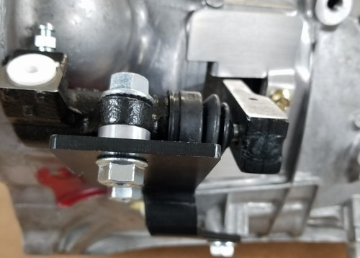
Step 6
Install Stainless Clutch hose to OEM hard pipe and slave cylinder AND ROUTE AWAY FROM EXHAUST AND STEERING KUNCKLE . Remove the 1 or 2 metal harness brackets (depending on model) from starter harnesses and zip tie harness to slave bracket. You can route the harness between bracket and transmission.
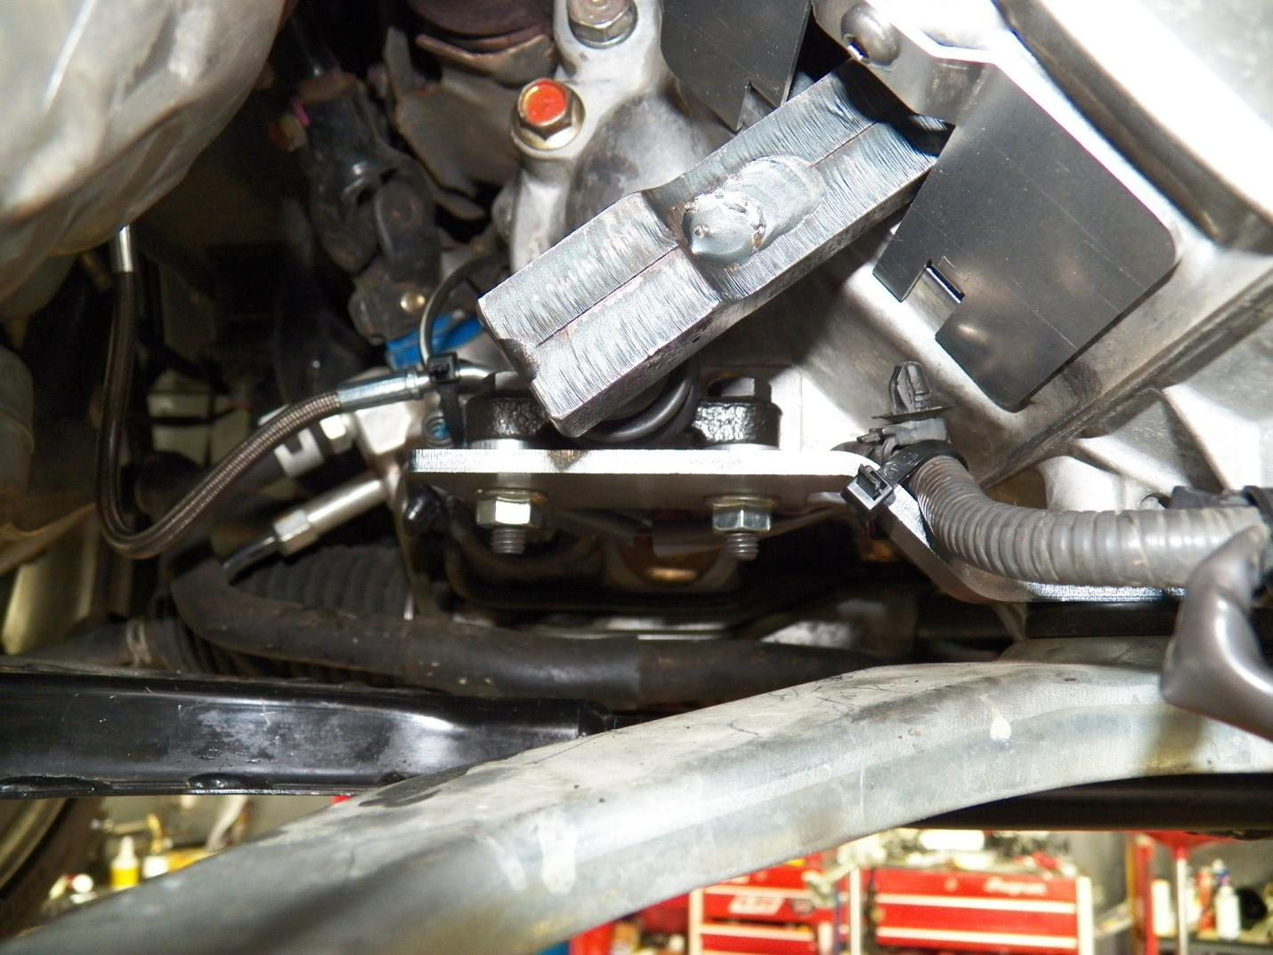
Follow normal bleeding procedures to bleed hydraulic clutch system and e-brake applied test for proper clutch release.
Support 937-506-7224 Sales@ZSpeed.com

